Coastal urban ecology: Research gaps, challenges and needs.

Graells G1,2, Nakamura N3, Lagos N4, Celis-Diez Juan L.5 Gelcich S1,2

1 Pontificia Universidad Católica de Chile, Departamento de Ecología, Santiago, Chile.

2 Center of Applied Ecology and Sustainability (CAPES).

3 Australian Research Council Centre of Excellence for Coral Reef Studies, James Cook University, Townsville, QLD 4811 Australia.

4

5 Pontificia Universidad Católica de Valparaíso, Escuela de Agronomía, Quillota, Chile.

Abril 2020

## Abstract

Coastal urban areas have dramatically increased during the last decades. However, coastal research integrating urban areas are still scarce. To examine research advances and critical gaps, a systematic review of the literature on coastal urban ecology was performed. Articles were selected following a structured decision tree and data were classified into main research themes, countries, types of cities, Pickett’s paradigms *in-*, *of-*, and *for- the city* among other categories.

From a total of 237 publications reviewed, results show that most of the research comes from USA, China, and Australia, and they have been carry out mostly in large cities with population between 1 and 5 million people. Focus has been placed on ecological studies, urban impacts and physical elements, non-human components, spatial and quantitative analysis. Most of the studies in coastal urban ecology were developed at near shore terrestrial environments. Coastal urban ecology has mainly performed research under the paradigm *in the city* which implies …..

These disciplinary, geographical, and environmental biases present a number of risks such as to lose the social component in the urban ecosystem, to use research from developed countries and large cities in the rest of the world, and to suppose that studies of the coast are only mostly terrestrial undermining the marine realm. Scientific research should diversify in ecology *of* and *for the cities*, in order to provide information to address urban coastal development in a diversity of countries and settings.

### In a nutshell:

• Population in coastal urban cities is increasing, however research has lagged behind.

• A literature review on coastal urban ecology shows that while studies have been increasing, most focus on ecological aspects. Few studies target social-ecological interactions and environmental policy-planning.

• Studies are disciplinary, geographically, and environmentally biased.

• Addressing critical biases in coastal urban ecology research is key to inform ongoing urbanization trends, especially in developing and mid-income countries.

## Introduction

The world’s population is increasing annually. In 2018, 55% of the human population lived in urban areas and cities have been constantly growing in number and size, forming large mega-cities with 10 million inhabitants or more (United Nations and Social Affairs 2018). The high levels of urbanisation during the last decades have triggered increasing research and policy interest on the impacts and sustainability of these human-dominated ecosystems (Grimm et al. 2000, Sustainable development goals, XX). Initial research believed urban areas were not able to sustain wildlife and complex ecological processes. However, this changed in the first part of the ’70s when urban ecology began studying species distributions in cities and its drivers (Sukopp 1998; Grimm *et al.* 2008). Since then, urban ecology research topics have evolved to include ecological and social science approaches (Grimm *et al.* 2000). Currently, urban ecosystems are recognized as a complex coupling of ecological processes and human dynamics (Alberti 2008). Research on urban ecology is diverse and includes, for example, studies on biodiversity patterns (e.g. urban biodiversity in Faeth *et al.* 2011; biotic homogenization in, McKinney 2006), species distributions (e.g. birds in Marzluff 2001), ecosystem functions (e.g. Alberti 2005), development processes (e.g. Antrop 2003), drivers of change (e.g. Grim *et al.* 2008), human perceptions (ref), extinction of experience (ref) and environmental policy (ref).

Recently, Pickett *et al.* (2016) introduced three phases in urban ecology evolution, as belonging to different paradigms which were termed: *in*, *of*, and *for* the city. Each one of these paradigms expose historical differences according to changes in urban ecology research, and result by the comparison of three variables or axes: chronology, model approach, and complexity. Studies under the paradigm *in the city* fall mainly into using ecological approaches, studies *of the city* are mainly based on social-ecological interactions, and studies *for the city* represent research about environmental policies and planning. The urban ecology paradigms also represent increasing complexity of the types of knowledge synthesised in the research questions. Studies which subscribe to the *of the city* paradigm contemplate interdisciplinary research; the urban ecology *for the city* is more intricate and includes *in* and *of the city* studies, engaging scientific knowledge in practice and for action (Pickett *et al.* 2016).

Most of the theoretical and empirical developments in urban ecology have used green areas (e.g. Chiesura 2004, Tzoulas *et al.* 2007, Wolch *et al.* 2014), freshwater streams (e.g. Allan et al. 1997, Paul & Meyer 2001, Walsh et al. 2005), and birds (e.g. Blair *et al.* 1996, Chace & Walsh 2004) and plants (e.g. Ulrich 1984, Donovan & Prestemon 2012, Donovan et al 2013) as their preferred research subjects. Coastal settings and species have not received the attention they deserve. This is unfortunate as coastal cities seem to be one of the preferred places for people to settle (Weinstein 2009). In fact, 40% of the world’s population live less than 100 Km from the sea (United Nations 2017), with coastal cities growing 6.6 times between 1945 and 2012 (Barragán and Andrés 2015). Accordingly, there is a need to synthesize urban ecology research that has been carried out on the coast and assess critical gaps and biases, challenges and future research needs.

This article reviews coastal urban ecology scientific publications with the aim of examining spatial and temporal changes in time. Studies are classified according to theoretical and empirical dimensions of urban ecology. Biases in the literature are highlighted as a way to call attention on the needs for developing coastal urban ecology studies that can inform ongoing urbanization trends, especially in developing and mid-income countries.

**Methods**

A systematic review of the literature was performed through the Web of Science (<https://webofknowledge.com/>). Eligibility criteria included any publication following keywords in topic: (“urban ecology” or “urban environment”) and (coast or marine), where words as “environment” and “coast” were truncated to use their derivations. The period of the search included from 1975 until December 2019. Selection of articles was made with a decision tree (Fig. 1), where the research areas urban centre, marine studies, and biodiversity approach had to be checked for any articles to be included. Fulfilling the requirement to be a “coastal urban ecology” study, publications were classified in ecology *in the city*, ecology *of the city* or ecology *for the city* following the paradigms established by Pickett *et al.* (2016). Grey-literature was not incorporated in the selection.

Each article collected was categorized in 16 sections: publication year, author’s name, type of publication, author´s affiliation country, study country, study city, city size, model, habitat, ecological paradigm, type of analysis, disciplinary focus, component, approximation, and study subject. In particular, categories as publication year, author’s name, type of publication, author´s affiliation country, study country, and study city were factors obtained directly from each paper, the rest of them had to be checked with further reading.

City’s population data were obtained from Brinkhoff (2018). Urban centres classification was modified from United Nations and Social Affairs (2014) and Barragán and Andrés (2015). This classification comprehends 1) Non-urban areas, which have less than 100,000 inhabitants, 2) small cities, between 100,000 and 500, 000 inhabitants, 3) medium cities, between 500,000 and 1 million, 4) large cities, between 1 and 5 million, 5) very large cities, between 5 and 10 million, and 5) megacities, with more than 10 million.

The rest of the categories (model, habitat, type of analysis, disciplinary focus, study component, approximation of the research, study subject, and ecological paradigms) were classified by two the authors independently. Study model refers to the minimum unit which was studied in each article, including three significant areas: physical, biological, and social. Here, physical space comprises research with different kind of pollutants, remote sensing data, water resources, physical risk models, and anthropogenic constructions, among others; social with human activities, perceptions and reactions, health, aspects of demography, and city development, among others; and biological with different taxa as birds, plants, invertebrates, mammals, and fishes, among others. “Others” category include environmental management, theoretical ecology, ecosystems.

Study habitats were divided in relation with the coastal environment where the research was performed or focused. The classification includes four main areas according to Burke *et al.* (2001): 1) Near-shore terrestrial, which includes dunes, coastal xeromorphic habitats, rocky and sandy shores, urban, agricultural and industrial landscapes; 2) Intertidal, with estuaries, deltas, mangrove forests, lagoons, salt marshes, other coastal wetlands, marinas and ports; 3) Benthic, with seagrass beds, artificial structures and soft bottom environments above the continental shelf; 4) Pelagic, with open waters above the continental shelf. To this classification the component “urban atmosphere” was added because the amount of studies focused on this habitat.

Study subject summarises the central theme of each article. Study subject was catergorized into eight sections: 1) Anthropogenic pollution, 2) urban impacts, 3) changes in shoreline, 4) habitat use, 5) human adaptation and sustainability, 6) demographic changes , 7) natural disaster, 8) and city design.

Disciplinary focus was categorized into five sections where inter-disciplines were considered. The five disciplinary focus were: 1) Ecology: Study of relationships and interaction between organisms and their coastal urban environment, 2) Sociology: Study of social behaviour, including its origin, evolution and organization within a coastal urban environment, 3) Study of interaction between humans and their coastal urban environment, multidiscipline including anthropology, geography, sociology and ecology, 4) Environmental policy: Study of environment, to organize, manage the laws, regulations or find a solution, 5) Social-policy: Provides practical guidelines and principles to improve human welfare.

Study component was divided in three classes: abiotic, biotic, and human. These three presented combinations that were considered as well: abiotic-biotic, abiotic-human, biotic-human, and abiotic-biotic-human.

Approximation of studies was categorised in three: temporal, spatial, spatiotemporal, and experimental (referring to laboratory studies). Type of analysis comprises quantitative (descriptive analysis), qualitative (collecting and evaluating measurable data) or modelling studies (mostly computational simulations). Finally, type of analysis comprehended modelling, qualitative and quantitative analysis.

To examine interaction among articles paradigms through quotation, a network analysis was made with the information provided by Web of Science. The analysis included extracting every reference from each article that was selected in this review andt he selection of quoted articles that were already part of the article selection. Consequently, there was a tagging for each article quoted with corresponding paradigm classification and plotting with the relationship among paradigms quotation.

Population data from coastal cities was obtained from Brinkhoff (2018) and a map was made using this information and the total number of articles published under coastal urban ecology selected in this review.

Classification, data analysis, and figures were prepared in R (Team R Core 2018). For data analysis, packages tidyverse (Wickham 2017a), dplyr (Wickham *et al.* 2017), purrr (Henry and Wickham 2017), broom (Robinson 2017), and stringr (Wickham 2017b) were used. Graphs and maps were plotted with ggplot2 (Wickham 2009) and gridextra (Auguie 2016). Network analysis was developed with package bibliometrix (Aria and Cuccurullo 2017) which allowed modifications in the code to create a new relationship between articles and their co-citations.

## Results: Coastal urban ecology tendencies

Coastal urban ecology studies that met the defined keywords included a total of 237 articles from 51 countries, involving 137 different coastal cities. Form those, most of the research was carried out in three countries: USA presenting 38 articles published, which included 20 different cities, China with 20 articles from 10 different cities , and Australia also with 20 articles, including 10 different cities (Fig. 2). The timeline of publications shows that coastal urban ecology appeared for the first time in 1979. However, it was not until 1995 that another study related to the field was published. Between 1995 and 2005, the number of publications was below five articles per year. After 2005 more articles can be found, particularly in years 2016 and 2019 which showed more than 20 publications per year. The publications are mostly journal articles with 84.97% of the total, proceedings papers represented 9.7%, book chapters 2.11%, and reviews 2.11%, as well.

Figure X shows the number of research articles published a year associated to different clasifications. The main disciplinary focus of research has consistently come from ecology with an average representation of X% of studies for the whole study period. Studies have mainly considerd spatial scales such as XXXXX (NO SE QUE ES SPATIAL, PONER EJEMPLO DE ALGUNOS PAPERS) and have increasingly included temporal dimensions. Quantitative studies have dominated the literature during the past 10 years. Modelling studies which QUE HACEN have begun to be included in the past 4 years. When looking at the main study subject it is interesting to note that the study of pollution and human impacts and human adaptations have dominated the literature. These articles mainly research….. DE QUE SE TRATAN!.

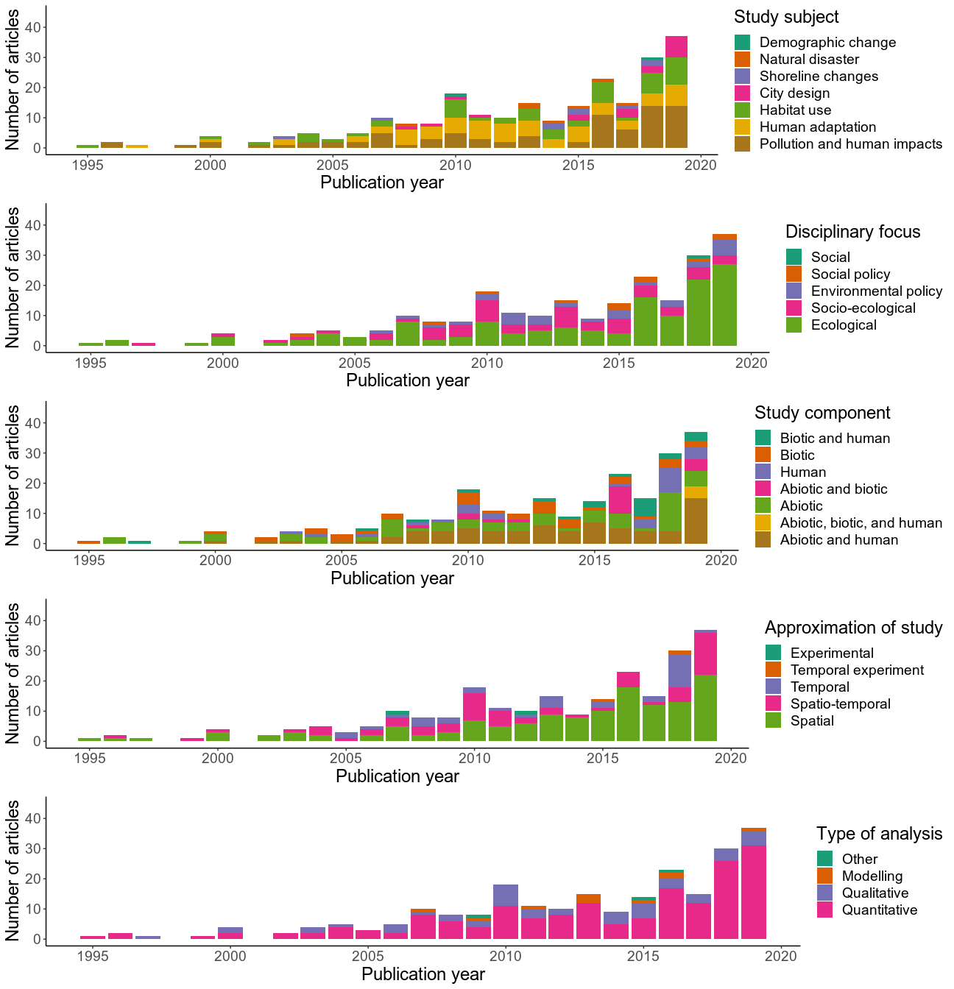

CAMBIAR ORDEN DE GRAFICOS: 1ero disciplinary focus; Aproximation of study; type of analysis study component y finalmente study subject.

According to study models a significant number of publications were focused on physical aspects (52.74%) such as pollutants, risk towards natural hazard measurements. Many studies used remote sensing approaches (%). These were followed by biologically focused studies (21.94%) such as birds, invertebrates, and plants, and social (16.03%) such as bioclimatic confort, human activities and cultural heritage, and sustainable cities (Fig. 5). Considering all the study models, pollutant measurments studies showed the highest number of articles (16.46%), followed by risk measurments (9.71%), and birds (9.28%). Additionally, mentions about contamination in this review showed that pollution was present in 35% of the articles, being atmospheric pollution the most common referenced and natural disasters in 18% of the articles, being flooding the most common.

During the years, most of the articles published in coastal urban ecology have been developed in urbanized areas between 1 and 5 million inhabitants, considered in this article as “large cities”. Exploring city size, coastal areas with less than 100,000 inhabitants presented the lowest number of publications (Fig. 3). The distribution of research according to cities’ population show to be heterogeneous and ranges from Shishmaref in the US, with 254 people, to Tokio, Japan, with more than 20 million people. Heterogeneity can also be observed within countries with research performed in more than one city. Highest dispersion was shown by Japan (areas between 990,285 and 22 million people), India (areas between 201,026 and 15,8 million people), and China (areas between 555,693 and 14,7 million people) (Fig. 4).

Most of the research in coastal urban ecolgy was developed at near shore terrestrial environments, presenting more than 160 articles (Fig. 6). This is followed, in a decreasing order, by intertidal areas, coastal atmosphere, benthic, and pelagic environments.

## Coastal urban ecology *in*, *of*, and *for the city.*

Paradigms *in*, *of*, and *for the city* have been addressed globally (Fig. 7). The focus *in the city* is presented in 60.34% of reviewed articles, including 37 countries. The US showed the highest number of articles with 29 publications. The focus *of the city* is shown at a lower percentage than the previous paradigm. With 20.25% of publications, performed in 21 countries. The US also dominated this theme with 9 articles. Investigations focused on *for the city* represented 19.41% of total articles and came from 25 different countries. China presents six articles, which is the highest number of papers in a country which addresses this paradigm.

During the years, paradigms *in*, *of*, and *for the cities* have shown differences, not only in the total number of articles published (143, 48, and 46, respectively), but also in their first year of publishing and tendencies (Fig. 8). In this way, it is not until 2004 that the paradigm *for the city* was developed in coastal urban ecology studies. Before that, the paradigm *in the city* (since the beginning in 1979) dominated this research area, with some occurrence of the paradigm *of the city* only since 1997. The three paradigms showed to be increasing the number of publications during the years, although paradigm *in the city* is doing it faster than the others.

Evidence suggests that the three paradigms are different according to study subject, disciplinary focus, and study components presented in their articles. (Fig. 9). Urban impacts and changes in coastal habitat use are the dominant themes in studies under the paradigm *in the city*. Human adaptation and urban impacts are the most prominent themes in studies under the paradigm *of the cities*. Human adaptation and city design are the mayor subjects in investigations under the paradigm *for the cities*, reflecting the focus on policy and planning implications of these studies. As expected, categorization by discipline showed that the paradigm *in the city* is mostly focused in ecological research, paradigm *of the city* in socio-ecological research, and paradigm *for the city* is divided in socio-ecological studies and social an enironmental policies.

S Spatial studies are the most common in coastal urban ecology, irrespective of the research paradigm in which papers were classified. Temporal research is generally lacking in coastal urban ecology studies. Spatio-temporal approximation is also present, without many differences among paradigms. Considering the type of analysis of publications, there is a greater number of quantitative analysis in studies *in the city*. Studies *of* and *for the city* show similar proportions between quantitative and qualitative analysis.

When analysing the whole database of coastal urban ecology articles, only 34 publications presented connections among citations, presenting a total of 24 interactions (Fig. 10). Besides the publication that cited only one other article, there are three other cases: when four articles cited the same article (Leclerc and Viard 2018, Heery et al. 2018, Bertocci et al. 2017, Bugnot et al. 2019), when three articles cited the same article (Shepard et al. 2016, Washburn et al. 2013, Campbell 2010), and when two articles cited the same article (Chen et al. 2018, Lopes *et al.* 2011). On the contrary, there are six cases where one unique article cited two articles. Network analysis showed a marginal interaction among articles’ paradigms. The paradigm *in* quoted seven *in* articles, two *of*, and seven *for the cities* studies. Only one article *of* quoted *of the cities* articles, three cited *for* articles, and three *in the city* studies. Only one article was classified as a paradigm *for* and it cited paradigm *of the cities*. These results suggest that coastal urban ecology article quotation have a subtle connection among publications, however this is not reinforced when the three paradigms are considered, and they do not show an order of complexity.

## Discussion

Coastal urban ecology encompasses a diversity of disciplines and research models aimed at understanding the links between the natural and built environments. Results show coastal urban ecology is also addressing issues which relate to planners and policy makers through a focus on human dimensions and some key studies on green infrastructure, eco-cities and sustainable cities. Results also show that coastal urban ecology has focused primarily on ecological studies and those studying physical characteristics of urban coasts dominated by research on pollution. However, there is an increasing contribution of studies on social dimensions. Studies that address the coastal urban ecology from an “in” the city perspective have significantly increased during the last 3 decades. Despite the diversity of research on coastal urban ecology there are still important geographic, disciplinary and gaps in the main focus of research.

PARAFO DE DISCUSION EN TORNO A FIGURA NUEVA:

Results show that most articles focused on pollutants (Fig. 5). The focus on pollution has maintained during the whole period being analysed. Thirty five percent of total articles dealt with pollution, mainly atmospheric and marine. Accordingly the effects of urbanization over sea breeze and the reactions of aerosols have had an important boom in this line of research (Castro *et al.* 1999, Mejia & Morawska 2009, Shanquan *et al.* 2016, Pushpawela *et al*. 2018). ALGO MAS DE POLUTION?

Risk assessments towards natural disasters and particularly flooding represented approximately 18% of the studies (Fig. 5; e.g. Goh 2019, Patel *et al* 2019). These studies were performed mainly in XXXXXXXXXXX (poner paises). Natural disasters relate to a city’s vulnerability (Chang & Huang 2015). While research has been performed in developed countries, developing ones are the most vulnerable in terms of natural disasters in coastal zones, particularly with flooding events (Ogie *et al.* 2020). This same tendency is repeated in relation to studies which address mitigation strategies, with projections to make cities more resilient to natural disasters (Watson & Adams 2010, Serre *et al.* 2016, Aerts *et al.* 2014, Sutton-Grier *et* *al.* 2015). There is an urgent need to extend this type of research towards developing and mid-income countries.

Our review shows that published research on coastal urban ecology has mainly focused in cities between 1 and 5 million people in 51 different countries. More than X% of articles being performed in USA, China and Australia (Fig. 2). Interestingly, studies indicate research in several cities from these three countries (20 cities in USA, 11 in China, and 10 in Australia), aiding to draw conclusions over different realities. While results from these specific studies can be important to develop theoretical frameworks and assess specific impacts, the focus on these high GDP countries makes it hard to extend insights to other cities in developing and mid-income countries, where growth dynamics, institutional support and adaptive capacity are very different. We therefore strongly advocate for the need of support programs for coastal urban ecology research in these settings. In addition, research in cities smaller than 1 million inhabitants or larger than 10 million would extend the variation of conditions in terms of the size of the human group and configuration of variables. These programs could take the form of regionally based learning platforms……

Temporal bias towards short studies.

Research has been mainly performed in near-shore terrestrial environments. The lack of information in coastal-marine urban environments, revealed a lack of integration in a relevant interphase for urban areas (seawater-land configuration and dimensionality). The results can be translated as marine environments in urban areas are not fully recognised as a conservation biology priority generating segregation between urban and marine ecology (Bulleri 2006), even when marine ecosystems are also affected by urbanization (Bulleri 2006, Shochat *et al.* 2006). Thus, a proper urban ecology developed in coastal cities, including the interaction between marine and terrestrial realms, may help to understand impacts of urbanization on coastal cities.

In coastal urban ecology, more than half of the articles can be classified as belonging to the paradigm *in the cities* Studies contributing to this paradigm have been growing in number, faster than the other paradigms, during the last years (Fig. 8). This result synthesizes the main biases found in this review which relate to the focus on ecological research, understanding urban impacts such as pollution, the non-human components, spatial and quantitative analysis found in most of the articles reviewed (Fig. 9). Only 20% of the articles in coastal urban ecology focused on interdisciplinary research such as socio-ecological studies (included in the paradigm *of the city).* This represents an important research gap associated to the lack of social knowledge in a system where humans are both objects and subjets of urbanization, who use space to live, extract subsistence and non-subsistence resources, perform recreational activities, and deposit waste, among other activities (Weinstein, 2009). Because of that, a lack of research on people with nature represents the loss of an integral part of the ecosystem (McDonnell *et al.* 1993; Rees 1997; Collins *et al.* 2000), decoupling human dynamics and ecological processes of this urban ecosystem (Alberti 2008). Lessons from urban ecology in other systems have shown the importance of transitioning towards these interdisciplinary dimensions. Accordingly, coastal research in urban areas must advance in ……..

Coastal urban ecology does not present a connections between citations between articles from different approaches, therefore lacking a network of urban-coastal articles (Fig. 10). As Pickett *et al.* (2016) proposed for urban ecology evolution, the three paradigms present specific characteristics of research and are connected through an incremental complexity which could be seen in the quotation of articles. The imbalance among paradigms and the lack of network of citation among articles could represent a maturation issue of citation. Coastal urban ecology must improve and begin using other paradigms as fundamental building blocks. If this does not happen, , research under the paradigm *in the city* would not be used as a pillar of environmental knowledge, research under the paradigm *of the city* would not use those environmental elements to address the pillars of sustainability (Cadenasso and Pickett 2016), and research *for the city* would not use those pillars in sustainability to increase urban resilience as a main planning objective in cities (Musacchio 2009).

**Conclusion**

Overall, while urban impacts of population studies are important, coastal urban ecology necessarily operate in a human context. Therefore, coastal cities need to be seen from the point of view of people, their interaction with the environment and the implementation of concepts that contribute to sustainability in cities through public policies and planning. More research is needed focusing on the three paradigms, particularly with respect to creating an interconnected network of knowledge where socio-ecological research is based on ecological, and environmental policies consider ecological and socio-ecological studies. In addition, a better consideration of the diversity of cities, the integration across marine and terrestrial ecosystems, and the inclusion of developing country urban areas will be better prepared to support ongoing urbanization trends in coastal zones across the globe.

**References**

Aerts JC, Botzen WW, Emanuel K, Lin N De Moel H, & Michel-Kerjan EO. 2014. Evaluating flood resilience strategies for coastal megacities. *Science*, *344*(6183), 473-475.

Alberti M 2005. The effects of urban patterns on ecosystem function. International regional science review, 28(2), 168-192.

Alberti M 2008. Advances in urban ecology: integrating humans and ecological processes in urban ecosystems (No. 574.5268 A4). New York: Springer.

Alberti M, Marzluff JM, Shulenberger E, Bradley G, Ryan C, & Zumbrunnen C 2003. Integrating humans into ecology: opportunities and challenges for studying urban ecosystems. BioScience, 53(12), 1169-1179.

Allan D, Erickson D, Fay J. 1997. The influence of catchment land use on stream integrity across multiple spatial scales. Freshwater biology. 37(1):149-61.

Antrop M 2004. Landscape change and the urbanization process in Europe. Landscape and urban planning, 67(1-4), 9-26.

Aria M and Cuccurullo C. 2017. Bibliometrix: An r-tool for comprehensive science mapping analysis. Journal of Informetrics 11: 959–75.

Aronson MF, La Sorte FA, Nilon CH, Katti M, Goddard MA, Lepczyk CA, ... & Dobbs C 2014. A global analysis of the impacts of urbanization on bird and plant diversity reveals key anthropogenic drivers. Proceedings of the Royal Society B: Biological Sciences, 281(1780), 20133330.

Auguie B 2016. GridExtra: Miscellaneous functions for "grid" graphics.

Barragán JM and Andrés M de. 2015. Analysis and trends of the world’s coastal cities and agglomerations. Ocean & Coastal Management 114: 11–20.

Belant JL. 1997. Gulls in urban environments: Landscape-level management to reduce conflict. Landscape and urban planning 38: 245–58.

Bertocci I, Arenas F, and Cacabelos E et al. 2017. Nowhere safe? Exploring the influence of urbanization across mainland and insular seashores in continental portugal and the azorean archipelago. Marine pollution bulletin 114: 644–55.

Blair RB. 1996. Land use and avian species diversity along an urban gradient. Ecological applications 6: 506–19.

Bolton D, Mayer-Pinto M, and Clark G et al. 2017. Coastal urban lighting has ecological consequences for multiple trophic levels under the sea. Science of The Total Environment 576: 1–9.

Branoff BL. 2017. Quantifying the influence of urban land use on mangrove biology and ecology: A meta-analysis. Global Ecology and Biogeography 26: 1339–56.

Brinkhoff T. 2018. City populationhttp://www.citypopulation.de. Viewed 16 Mar 2019.

Bugnot AB, Hose GC, and Walsh CJ et al. 2019. Urban impacts across realms: Making the case for inter-realm monitoring and management. Science of the Total Environment 648: 711–9.

Bulleri F. 2006. Is it time for urban ecology to include the marine realm? Trends in ecology & evolution 21: 658–9.

Burke lautetta, Payne Y Kura, and Kassem K et al. 2001. Pilot analysis of global ecosystems: Coastal ecosystems. World Resources Institute.

Campbell M. 2010. An animal geography of avian foraging competition on the sussex coast of england. Journal of Coastal Research: 44–52.

Castro LM, Pio CA, Harrison RM, & Smith DJT. 1999. Carbonaceous aerosol in urban and rural European atmospheres: estimation of secondary organic carbon concentrations. *Atmospheric Environment*, *33*(17), 2771-2781.

Celis-Diez JL, Muñoz CE, and Abades S et al. 2017. Biocultural homogenization in urban settings: Public knowledge of birds in city parks of santiago, chile. Sustainability 9: 485.

Chace JF, & Walsh JJ 2006. Urban effects on native avifauna: a review. *Landscape and urban planning*, *74*(1), 46-69.

Chang LF, & Huang SL. 2015. Assessing urban flooding vulnerability with an emergy approach. *Landscape and Urban Planning*, *143*, 11-24.

Chen Y-C, Yao C-K, Honjo T, and Lin T-P. 2018. The application of a high-density street-level air temperature observation network (hisan): Dynamic variation characteristics of urban heat island in tainan, taiwan. Science of the Total Environment 626: 555–66.

Chiesura A. 2004. The role of urban parks for the sustainable city. Landscape and urban planning. 68(1):129-38.

Collins JP, Kinzig A, and Grimm NB et al. 2000. A new urban ecology: Modeling human communities as integral parts of ecosystems poses special problems for the development and testing of ecological theory. American scientist 88: 416–25.

Dallimer M, Irvine KN, and Skinner AM et al. 2012. Biodiversity and the feel-good factor: Understanding associations between self-reported human well-being and species richness. BioScience 62: 47–55.

Dickman AJ. 2010. Complexities of conflict: The importance of considering social factors for effectively resolving human–wildlife conflict. Animal conservation 13: 458–66.

Dominick D, Latif MT, and Juneng L et al. 2015. Characterisation of particle mass and number concentration on the east coast of the malaysian peninsula during the northeast monsoon. Atmospheric Environment 117: 187–99.

Donovan GH, & Prestemon JP. 2012. The effect of trees on crime in Portland, Oregon. Environment and behavior, 44(1), 3-30.

Donovan G H, Butry DT, Michael YL, Prestemon JP, Liebhold AM, Gatziolis D, & Mao MY. 2013. The relationship between trees and human health: evidence from the spread of the emerald ash borer. American journal of preventive medicine, 44(2), 139-145.

Faeth SH, Bang C & Saari S 2011. Urban biodiversity: patterns and mechanisms. Annals of the New York Academy of Sciences, 1223(1), 69-81.

Fuller RA, Irvine KN, and Devine-Wright P et al. 2007. Psychological benefits of greenspace increase with biodiversity. Biology letters 3: 390–4.

Gelcich S, Edwards-Jones G, and Kaiser MJ. 2005. Importance of attitudinal differences among artisanal fishers toward co-management and conservation of marine resources. Conservation Biology 19: 865–75.

Gelcich S, Godoy N, and Castilla JC. 2009. Artisanal fishers’ perceptions regarding coastal co-management policies in chile and their potentials to scale-up marine biodiversity conservation. Ocean & Coastal Management 52: 424–32.

Goh K. 2019. Urban Waterscapes: The Hydro‐Politics of Flooding in a Sinking City. *International Journal of Urban and Regional Research*, *43*(2), 250-272

Grimm NB, Grove JG, Pickett ST, & Redman CL. 2000. Integrated approaches to long-term studies of urban ecological systems: Urban ecological systems present multiple challenges to ecologists—pervasive human impact and extreme heterogeneity of cities, and the need to integrate social and ecological approaches, concepts, and theory. BioScience, *50*(7), 571-584.

Grimm NB, Faeth SH, and Golubiewski NE et al. 2008. Global change and the ecology of cities. science 319: 756–60.

Heery EC, Olsen AY, Feist BE, and Sebens KP. 2018. Urbanization-related distribution patterns and habitat-use by the marine mesopredator, giant pacific octopus (enteroctopus dofleini). Urban Ecosystems 21: 707–19.

Henry L and Wickham H. 2017. Purrr: Functional programming tools.

Leclerc J-C and Viard F. 2018. Habitat formation prevails over predation in influencing fouling communities. Ecology and Evolution 8: 477–92.

Lindemann-Matthies P, Junge X, and Matthies D. 2010. The influence of plant diversity on people’s perception and aesthetic appreciation of grassland vegetation. Biological Conservation 143: 195–202.

Li Y, Qiu J, and Zhao B et al. 2017. Quantifying urban ecological governance: A suite of indices characterizes the ecological planning implications of rapid coastal urbanization. Ecological indicators 72: 225–33.

Lopes A, Lopes S, Matzarakis A, and Alcoforado MJ. 2011. The influence of the summer sea breeze on thermal comfort in funchal (madeira). A contribution to tourism and urban planning. *Meteorologische Zeitschrift* 20: 553–64.

Lubchenco J, Olson AM, and Brubaker LB et al. 1991. The sustainable biosphere initiative: An ecological research agenda: A report from the ecological society of america. Ecology 72: 371–412.

Marzluff JM. 2001. Worldwide urbanization and its effects on birds. In: Avian ecology and conservation in an urbanizing world. Springer.

McDonnell MJ, Pickett ST, and Pouyat RV. 1993. The application of the ecological gradient paradigm to the study of urban effects. In: Humans as components of ecosystems. Springer.

McKinney ML. 2006. Urbanization as a major cause of biotic homogenization. Biological conservation 127: 247–60.

McKinney ML and Lockwood JL. 1999. Biotic homogenization: A few winners replacing many losers in the next mass extinction. Trends in ecology & evolution 14: 450–3.

Mejia JF, & Morawska L. 2009. An investigation of nucleation events in a coastal urban environment in the Southern Hemisphere. *Atmospheric Chemistry and Physics*, *9*(1), 2195-2222.

Ogie RI, Adam C & Perez P. 2020. A review of structural approach to flood management in coastal megacities of developing nations: current research and future directions. *Journal of Environmental Planning and Management*, *63*(2), 127-147.

Patel, P., Ghosh, S., Kaginalkar, A., Islam, S., & Karmakar, S. (2019). Performance evaluation of WRF for extreme flood forecasts in a coastal urban environment. *Atmospheric research*, *223*, 39-48.

Paul MJ, & Meyer JL. 2001. Streams in the urban landscape. Annual review of Ecology and Systematics, *32*(1), 333-365.

Pickett ST, Cadenasso ML, and Childers DL et al. 2016. Evolution and future of urban ecological science: Ecology in, of, and for the city. Ecosystem Health and Sustainability 2.

Pushpawela B, Jayaratne R & Morawska L. 2018. Differentiating between particle formation and growth events in an urban environment. *Atmospheric Chemistry and Physics*, *18*(15), 11171-11183.

Rees WE. 1997. Urban ecosystems: The human dimension. Urban ecosystems 1: 63–75.

Robinson D. 2017. Broom: Convert statistical analysis objects into tidy data frames.

Serre D, Barroca B, & Diab Y. 2010. Urban flood mitigation: Sustainable options. *WIT Trans. Ecol. Environ*, *129*, 299-309.

Shanahan DF, Fuller RA, and Bush R et al. 2015. The health benefits of urban nature: How much do we need? BioScience 65: 476–85.

Shanquan L, Zhang G, Yang J & Nan J. 2016. Multi-source characteristics of atmospheric deposition in Nanjing, China, as controlled by East Asia monsoons and urban activities. *Pedosphere*, *26*(3), 374-385.

Shepard EL, Williamson C, and Windsor SP. 2016. Fine-scale flight strategies of gulls in urban airflows indicate risk and reward in city living. Philosophical Transactions of the Royal Society B: Biological Sciences 371: 20150394.

Shochat E, Warren PS, and Faeth SH. 2006. Future directions in urban ecology. Trends in Ecology & Evolution 21: 661–2.

Soulsbury CD and White PC. 2016. Human–wildlife interactions in urban areas: A review of conflicts, benefits and opportunities. Wildlife research 42: 541–53.

Sukopp H. 1998. Urban ecology-scientific and practical aspects. In: Urban ecology. Springer.

Sutton-Grier AE, Wowk K, & Bamford H. 2015. Future of our coasts: The potential for natural and hybrid infrastructure to enhance the resilience of our coastal communities, economies and ecosystems. *Environmental Science & Policy*, *51*, 137-148.

Team R Core. 2018. R: A language and environment for statistical computing. dim (ca533) 1: 34.

Tibbetts J. 2002. Coastal cities: living on the edge. *Environmental Health Perspectives*, *110*(11), A674-A681.

Timmerman P, White R 1997. Megahydropolis: coastal cities in the context of global environmental change. Global Environmental Change 7(3): 205-234.

Tzoulas K, Korpela K, Venn S, Yli-Pelkonen V, Kaźmierczak A, Niemela J, James P 2007. Promoting ecosystem and human health in urban areas using Green Infrastructure: A literature review. Landscape and urban planning. 81(3):167-78.

Ulrich RS. 1984. View through a window may influence recovery from surgery. Science 224: 420–1.

United Nations TOC. 2017. Concept paper. Partnership dialogue 2: Managing, protecting, conserving and restoring marine and coastal ecosystems.

United Nations D of E and Social Affairs PD. 2014. World urbanization prospects: The 2014 revision. Highlights.

United Nations D of E and Social Affairs PD. 2018. World urbanization prospects: The 2018 revision. Key facts.

Vitousek PM, Mooney HA, Lubchenco J, Melillo JM. 1997. Human domination of Earth's ecosystems. Science. 277(5325): 494-9.

Walsh CJ, Roy AH, Feminella JW, Cottingham PD, Groffman PM & Morgan RP. 2005. The urban stream syndrome: current knowledge and the search for a cure. Journal of the North American Benthological Society, 24(3), 706-723.

Washburn BE, Bernhardt GE, and Kutschbach-Brohl L et al. 2013. Foraging ecology of four gull species at a coastal-urban interface: Ecologıa de forrajeo de cuatro especies de gaviota en una interface costera-urbana. The Condor 115: 67–76.

Watson D, & Adams M. 2010. *Design for flooding: Architecture, landscape, and urban design for resilience to climate change*. John wiley & sons.

Weinstein MP. 2009. The road ahead: The sustainability transition and coastal research. Estuaries and Coasts 32: 1044–53.

Wickham H. 2009. Ggplot2: Elegant graphics for data analysis. Springer-Verlag New York.

Wickham H. 2017a. Tidyverse: Easily install and load ’tidyverse’ packages.

Wickham H. 2017b. Stringr: Simple, consistent wrappers for common string operations.

Wickham H, Francois R, Henry L, and MÃ¼ller K. 2017. Dplyr: A grammar of data manipulation.

Wolch JR, Byrne J, Newell JP 2014. Urban green space, public health, and environmental justice: The challenge of making cities ‘just green enough’. Landscape and urban planning. 125:234-44.

Worldometers.info. 2020. <https://www.worldometers.info/faq/>. Dover, Delaware, U.S.A.

**Figures**

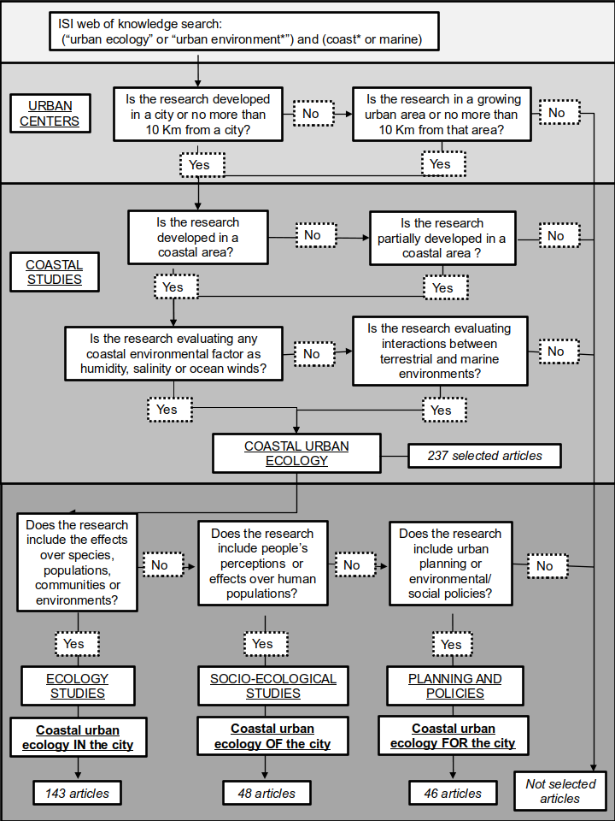Fig 1 : Decision tree of articles selected for coastal urban ecology in literature.

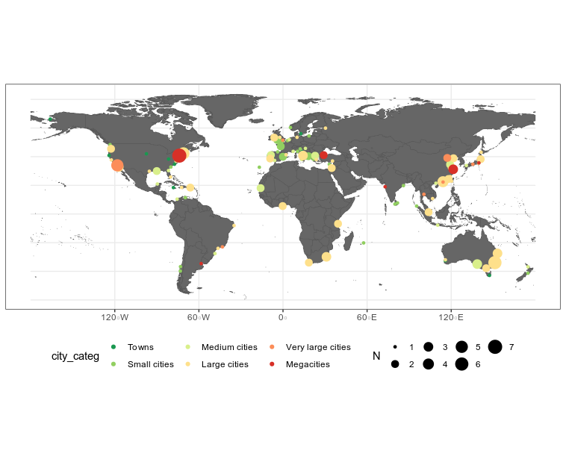*Fig 2.* *Map of the world where the articles published in coastal urban ecology are presented according to the city where the investigations were carried out, the population size of each city and the number of articles published in them. For each city the size of the circle represents the number of articles published (increasing size with the number of articles, from 1 to 7) and the color of the circle represents the size of the city given its population (city’s population data were obtained from Brinkhoff 2018 and urban centres classification was modified from United Nations and Social Affairs 2014 and Barragán & Andrés 2015).*

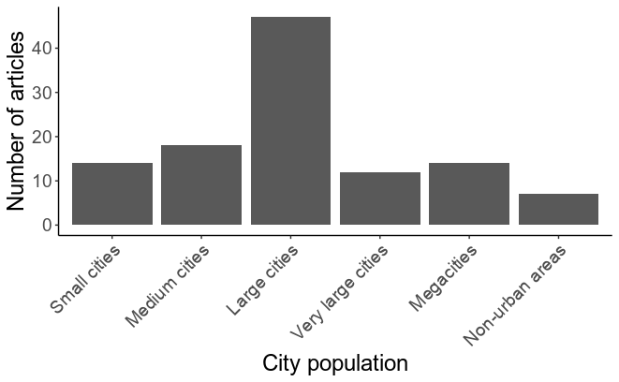Fig. 3: Number of articles for five types of urban centers classification in the world, where research in coastal urban ecology was made.

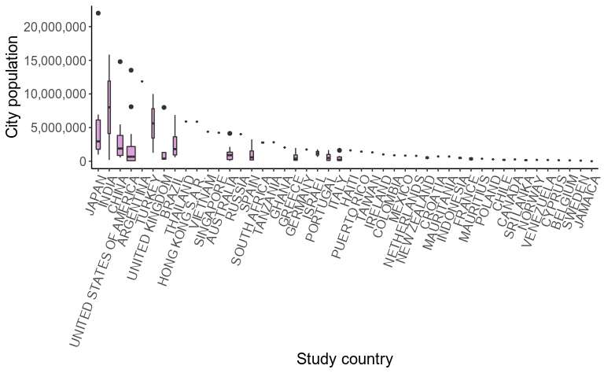Fig 4. Population distribution of studied cities in coastal urban ecology research, for each studied country.

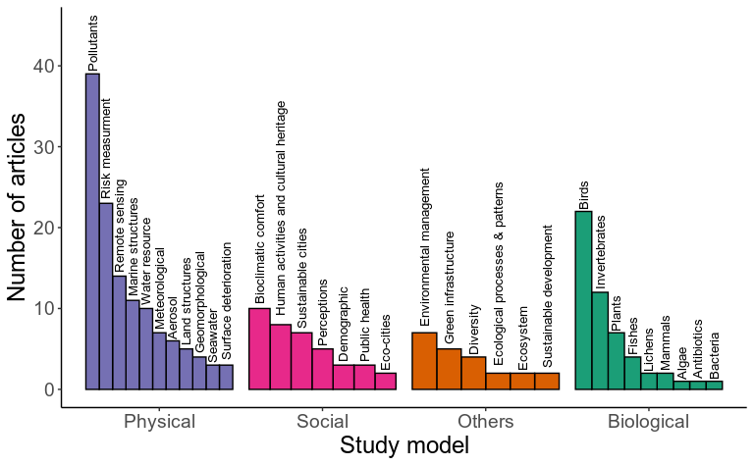

Fig 5. Distribution of articles, according to study models of research: Biological-species; Biological-ecosystem (categoria donde esta: ecosystem, ecological processes, diversity, environmental management); Physical; Social (pasar sustainable development); social-ecological-tecnological (Eco-cities, Green infrastructure, sustainable cities, PASAR Marine structures)

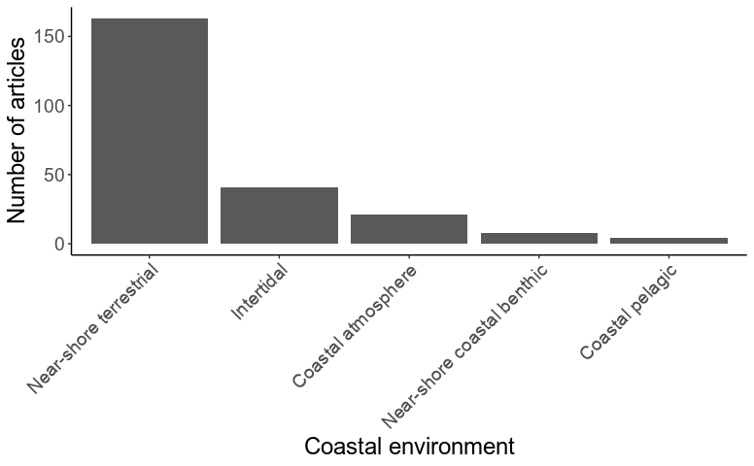

Fig 6. Distribution of articles, according to coastal environments, where research was done.

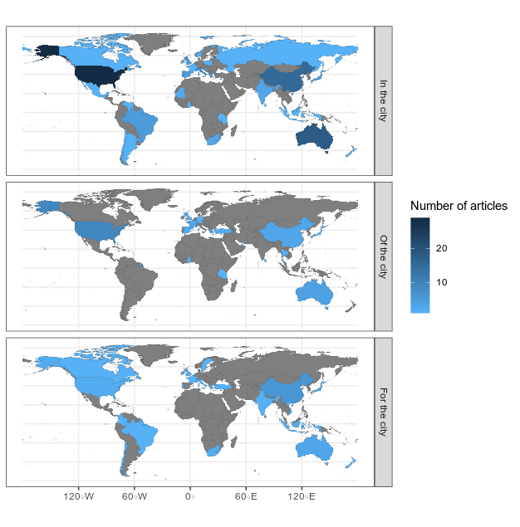

Fig 7. Ecological paradigms in, of, and for the city for coastal urban ecology, according to the number of studies developed in each country. Countries do not prepresented coastal urban ecological articules are show in grey, and those with publications are pretented in blue colours from light to dark.

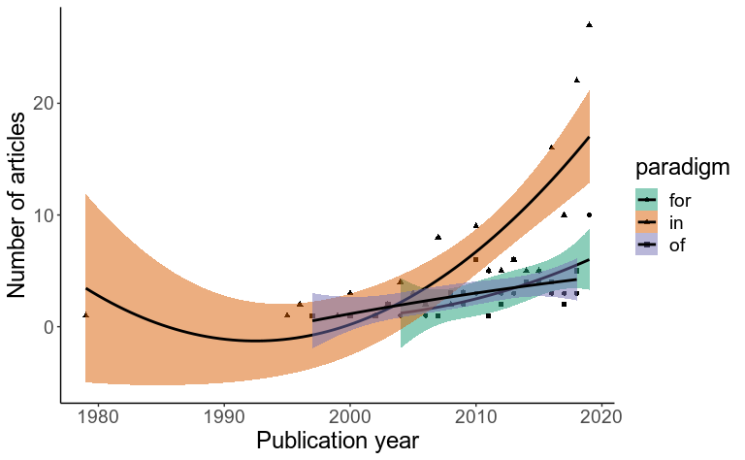

Fig 8. Number of articles published during the years considering paradigms in, of, and for the cities. Trend lines represent quadratic regression fit, colour areas represent the 95% confidence interval.

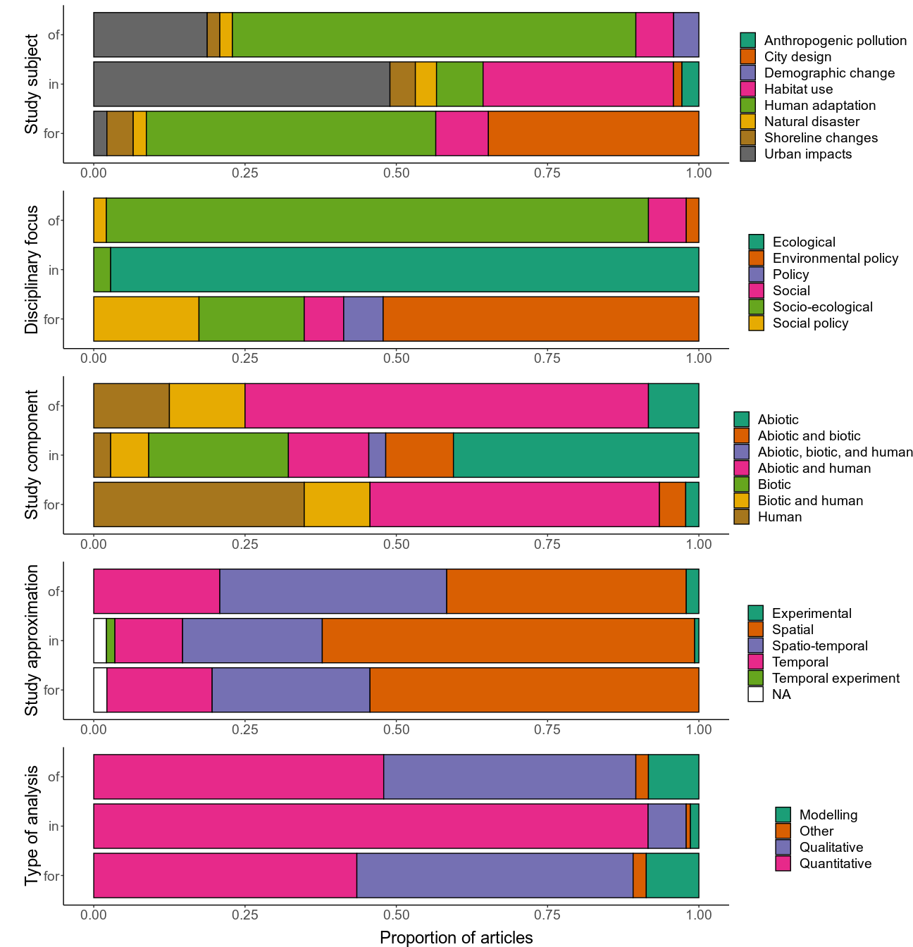

Fig 9. Distribution of articles’ paradigms according to study subject, study discipline, study component, approximation of the study, and type of analysis.

.

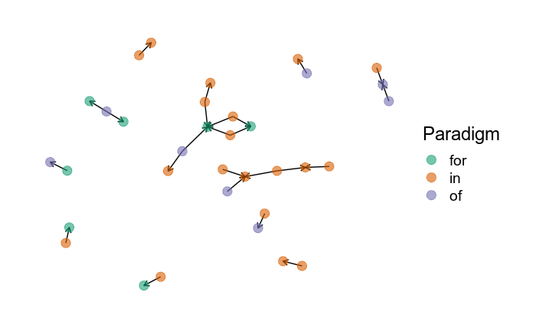

Fig 10. Network analysis for co-citations of articles presented in this coastal urban ecology review, considering the three paradigms proposed. Each dot represent a study and the colour indicates the paradigms (in-, of- and for- the cities). Directed edges go from the article citing to the article being cited.